Yehuda’s Guide to Commonly Confused Heraldic Terms

Term | Line of Division | Ordinary | Location | Arrangement | Orientation
 | Per X | A X |  | In X | X-wise
Fess – horizontal | Per fess | A fess | N/A | In fess | Fesswise
Fess – horizontal | 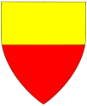 | 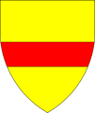 |  |  | 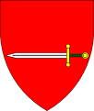
Pale – vertical | Per pale | A pale | NA | In pale | Palewise
Pale – vertical | 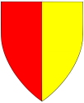 | 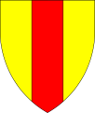 |  | 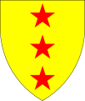 | 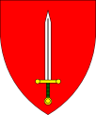
Bend – diagonal | Per bend | A bend | N/A | In bend | Bendwise
Bend – diagonal | 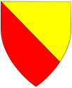 | 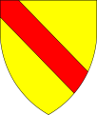 |  | 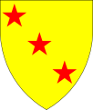 | 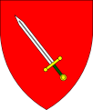
Bend sinister – diagonal | Per bend sinister | A bend sinister | N/A | In bend sinister | Bendwise sinister
Bend sinister – diagonal | 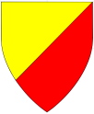 | 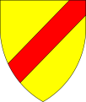 |  | 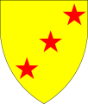 | 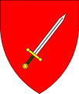
Chief – top | N/A | A chief | In chief | N/A | To chief
Chief – top |  | 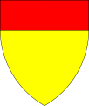 | 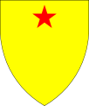
Base – bottom | N/A | A base | In base | N/A | To base/Inverted
Base – bottom |  | 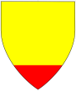 | 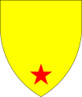 |  | 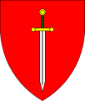
Dexter | N/A | A tierce | In dexter (rare) | N/A | To dexter
Dexter |  | 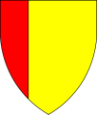 | 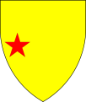
Sinister | N/A | A tierce sinister | In sinister (rare) | N/A | To sinister/reversed
Sinister |  | 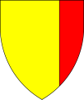 | 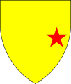 |  | 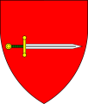
This image was created in 2014 by Juliean Galak. It is hereby released into the public domain. Page 1

Yehuda’s Guide to Commonly Confused Heraldic Terms

Term | Line of Division | Ordinary | Location | Arrangement | Orientation
 | Per X | A X |  | In X | X-wise
Canton | N/A | A canton | In canton | N/A | N/A
Canton |  | 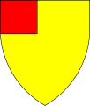 | 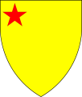
Canton sinister | N/A | A canton sinister | In canton sinister | N/A | N/A
Canton sinister |  | 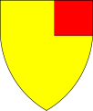 | 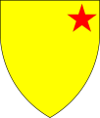
Cross | Quarterly | A cross | N/A | In Cross | In cross
Cross | 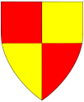 | 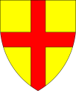 |  |  | 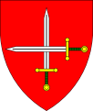
Saltire | Per saltire | A saltire | N/A | In saltire | In saltire
Saltire | 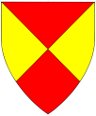 | 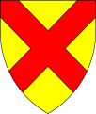 |  |  | 
Chevron | Per chevron | A chevron | N/A | One and two | In chevron
Chevron | 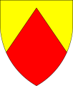 | 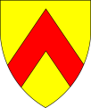 |  | 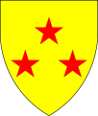 | 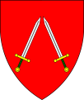
Chevron inverted | Per chevron inverted | A chevron inverted | N/A | Two and one | In chevron inverted
Chevron inverted | 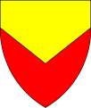 | 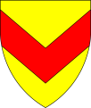 |  | 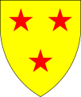 | 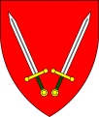
Pall | Per pall | A pall | N/A | In pall | In pall
Pall | 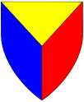 | 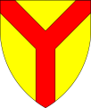 |  | 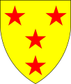 | 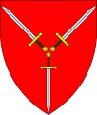
Pall inverted | Per pall inverted | A pall inverted | N/A | In pall inverted | In pall inverted
Pall inverted | 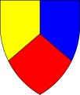 | 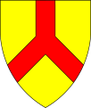 |  | 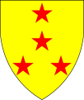 | 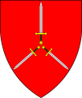
This image was created in 2014 by Juliean Galak. It is hereby released into the public domain. Page 2

